“Band together against addiction”
SUBSTANCE ABUSE is a significant issue that is affecting many of us in Maryland, including the Sparrows Point, Edgemere, and Dundalk communities. On May 1st we will have substance abuse treatment providers, people in recovery, and support group representatives participating in a panel discussion about substance abuse, ways to prevent use, treatment options, and answering YOUR questions.

Community Event: May 1, 2019, 6pm -7:30pm
Where: Battle Grove Elementary: 7828 Saint Patricia Ln
Who: Students and families of Sparrows Point High School, Sparrows Point Middle School, Chesapeake Terrace Elementary, Edgemere Elementary, Battle Grove Elementary, and surrounding communities.
Purpose: Provide resources to families/students affected by a loved one’s drug/alcohol abuse and those struggling with addiction.
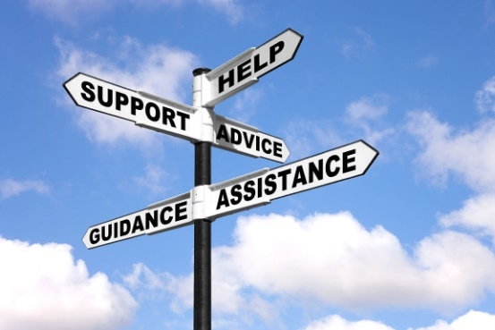
**Pizza and beverages will be provided.**

